**Trajectory of Golf Balls, Roughened Spheres and Smooth Spheres**

**May 12th, 2015.**

Benjamin Aldrich and Manish Manandhar

**Abstract**

Trajectories of spheres with different relative roughness were approximated by iterating a system of equations in vertical and horizontal motion. The range of those spheres were affected by various different forces, however, this project accounted the trajectories for force due to gravity, force due to drag and lift force due to spin.

**Introduction**

As a spherical object moves through air, it is acted upon by a drag force due to frictional interaction with the air. Because the coefficient of drag is dependent upon the speed of the ball, it is constantly changing throughout its trajectory. This change in drag coefficient is non-linear, and must be continually adjusted for varying velocities. Spheres of different relative roughness experience turbulence at different velocities, and undergo different changes in drag coefficient. Therefore, spheres having different relative roughness should have different ranges.

Furthermore, unless the sphere is travelling with no spin, it will experience a lift force due to pressure differences caused by its rotation. This lift force acts normal to the plane formed by the velocity and angular velocity vectors, and can change the trajectory drastically. A ball travelling with backspin experiences an upward lift, increasing the range of the trajectory for angles and velocities similar to those of typical golf drives. On the other hand, a ball experiencing topspin is pushed down by the lift force and has a shorter range. The goal of this project was to model trajectories of spheres with different relative roughness, taking into account the forces of drag and lift.

**Analysis Methods**

In this project, the trajectory of a golf ball was compared to a rougher sphere and a smooth sphere. Then, trajectories were compared for golf balls at different initial speeds and rotation rates. Since, the change in altitude for the trajectories was less than 50 meters the density of air only varied by about 0.30%. Therefore, density of air was considered to remain constant throughout all the trajectories. Mass, diameter and incident angle remained constant for each sphere with different relative roughness.

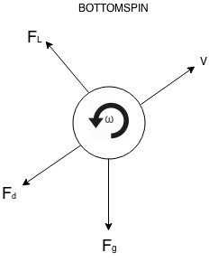 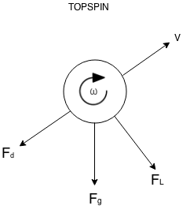

Figure : Forces on a ball with bottom spin Figure : Forces on ball with top spin

In figures 1 and 2, the drag force is given by,

$$F_{d}=\frac{1}{2}ρ_{o}C_{d}\left(\frac{π D^{2}}{4}\right) V^{2}$$

where, $F_{d}$ is the magnitude of drag force acting on a sphere, $ρ_{o}$ is the density of air, $C_{d}$ is the coefficient of drag, D is the diameter of the sphere, and $V$ is magnitude of velocity of the ball. Breaking the drag force into its x and y components,

$$F_{dx}=\frac{1}{2}ρ_{o}C_{d}\left(\frac{π D^{2}}{4}\right) V^{2}Cos\left(θ_{o}\right)=\frac{1}{2}ρ_{o}C_{d}\left(\frac{π D^{2}}{4}\right) V u$$

$$F_{dy}=\frac{1}{2}ρ_{o}C_{d}\left(\frac{π D^{2}}{4}\right) V^{2}Sin\left(θ_{o}\right)=\frac{1}{2}ρ_{o}C_{d}\left(\frac{π D^{2}}{4}\right) V v$$

According to the Kutta-Joukowski’s lift theorem, the force of lift on a rotating cylinder in a moving fluid is given by,

$$F_{L}=ρ Γ V$$

where, $F_{L}$ is the force of lift, $ρ$ is the density of the fluid, $V$ is the velocity of the fluid with respect to the ball, and $Γ$ is circulation. Circulation is given by,

$$Γ=2 π r V_{r}$$

where, $r$ is the radius of the cylinder and $V_{r}$ is the speed of the surface of the cylinder, which is given by,

$$V_{r}=2 π r f$$

where, $f$ is the revolution rate of the cylinder (in revs/sec). Substituting this back into the circulation function gives

$$Γ=4 π^{2} r^{2} f$$

Substituting this back into the Kutta-Joukowski’s lift equation, the following relationship is obtained for lift on a rotating cylinder

$$F_{L}=4 π^{2} r^{3} f ρ V$$

To model the flight of a golf ball, this formula was adjusted to fit a rotating sphere by integrating along the axis of rotation to produce a sphere by combining cylinders of different radii.

$$F_{L}=\int_{-r}^{r}{4 π^{2} r^{3} f ρ V dl}$$

where,

[1]

Therefore, lift force acting on a sphere is given by,

$$F_{L}=4 π^{2} {r_{o}}^{3} f ρ V\int_{0}^{π}{ {Sin}^{3}\left(ϕ\right) dϕ}$$

$$F_{L}=\frac{16}{3} π^{2} {r_{o}}^{3} f ρ V$$

For iterations, using Rory McIllroy’s drive speed at an 10-degree angle[3],

where, $\left|\overset{⃑}{V_{o}}\right|$ is the initial velocity.

$$θ_{o}={10}^{°}$$

where, $θ_{o}$ is the initial angle.

$$u_{o}=\left|\overset{⃑}{V_{o}}\right| Cos\left(θ_{o}\right)$$

$$v_{o}=\left|\overset{⃑}{V_{o}}\right| Sin\left(θ_{o}\right)$$

where, $u_{o}$ and $v_{o}$ are initial velocities in x and y directions, respectively.

$$∆t=5×{10}^{-5} s$$

where, $∆t$ is the step size,

$$u_{i}=u_{i-1}+a_{x i-1} ∆t$$

$$v_{i}=v_{i-1}+a_{y i-1} ∆t$$

where, “i” is the step number in the iteration sequence.

$$\left|V_{i}\right|= \sqrt{{u_{i}}^{2}+ {v_{i}}^{2}}$$

where, $\left|V_{i}\right|$ is the magnitude of velocity at *i*th iteration.

$${Re}_{i}=\frac{ρ_{o}\left|V_{i}\right| D}{μ}$$

where, ${Re}_{i}$ is the Reynolds number at *i*th iteration, $ρ_{o}$ is the density of air, D is the diameter of the ball, and $μ$ is the viscosity of air. For each of the spheres, a fit was obtained for the coefficient of drag as a function of Reynolds number by applying linear model fits for ranges of Reynolds numbers where the trend was apparently linear, as shown in Figure 3.

$${Cd}_{i}=\left\{\begin{aligned}\begin{aligned}\begin{aligned}1.341 × {10}^{-7} {Re}_{i}+0.2339, 1×{10}^{5}< {Re}_{i}<2 ×{10}^{5} \\ 2.235 × {10}^{-7} {Re}_{i}+0.2250, 8×{10}^{4}< {Re}_{i}<10 ×{10}^{4} \\ -7.500 × {10}^{-8} {Re}_{i}+0.2488, 7×{10}^{4}< {Re}_{i}<8 ×{10}^{4} \\ -1.117× {10}^{-6} {Re}_{i}+0.3218, 6×{10}^{4}< {Re}_{i}<7 ×{10}^{4}\end{aligned} \\ -2.905× {10}^{-6} {Re}_{i}+0.4291, 5×{10}^{4}< {Re}_{i}<6 ×{10}^{4}\end{aligned} \\ -2.048× {10}^{-5} {Re}_{i}+1.308, 4×{10}^{4}< {Re}_{i}<5 ×{10}^{4}\end{aligned}\right\}$$

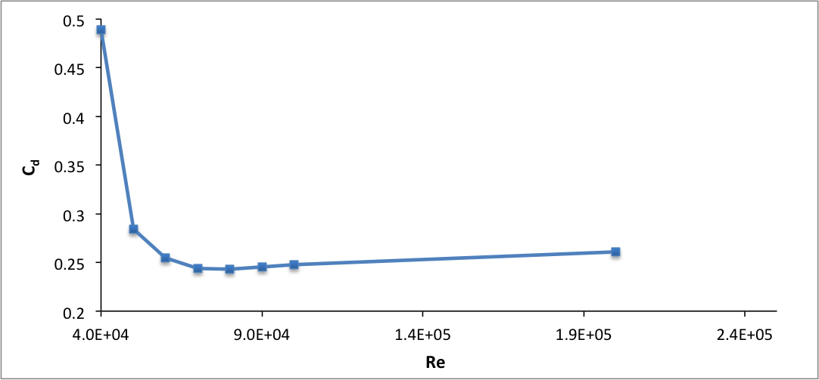

Figure : Fit for Cd of a golf ball, using linear approximation method

Similarly, for a roughened sphere (/D=1250 x 10-5),

For a smooth sphere (/D=1250 x 10-5),

The drag forces in x and y directions were calculated using,

$$F_{dxi}=\frac{1}{2}ρ_{o}C_{di}\left(\frac{π D^{2}}{4}\right) \left|V_{i}\right| u_{i}$$

$$F_{dyi}=\frac{1}{2}ρ_{o}C_{di}\left(\frac{π D^{2}}{4}\right) \left|V_{i}\right| v_{i}$$

where, $F_{dxi}$ and $F_{dyi}$ are the drag forces at *i*th iteration in x and y direction respectively. The lift forces in x and y directions were calculated using,

$$F_{Lxi}=-\frac{16}{3} π^{2} r^{3} f_{o} ρ_{o} v_{i}$$

$$F_{Lyi}=+\frac{16}{3} π^{2} r^{3} f_{o} ρ_{o} u_{i}$$

where, $F_{Lxi}$ and $F_{Lyi}$ are the lift forces at *i*th iteration in x and y direction respectively.

$$a_{xi}=\frac{F_{dxi}}{m_{o}}+\frac{F_{Lxi}}{m_{o}}$$

$$a_{yi}=\frac{F_{dyi}}{m_{o}}+\frac{F_{Lyi}}{m_{o}}-g$$

where, $a_{xi }$ and $a_{yi}$ are acceleration at *i*th iteration in x and y directions respectively. Lastly, the position of the spheres was given by,

$$x_{i}=x_{i-1}+u_{i-1}∆t+a_{x i-1} {(∆t)}^{2}$$

$$y_{i}=y_{i-1}+v_{i-1}∆t+a_{y i-1} {(∆t)}^{2}$$

The trajectories were obtained by plotting $y_{i}$ vs $x_{i}$.

**Result**

As seen in Figure 4, comparing the trajectory of a golf ball to those of a smooth and a rough sphere, for a professional golfer’s drive, shows that the golf ball carries significantly farther. Given their respective drag curves, a smooth sphere is not expected to outfly a golf ball under any reasonable conditions.

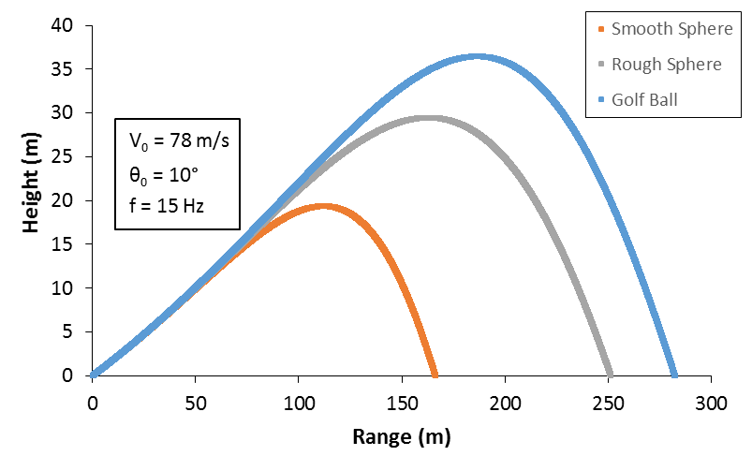

Figure : Trajectories of a smooth sphere (/D=0), rough sphere (/D=1250 x 10-5) and a golf ball(/D=900 x 10-5)

The trajectories for golf balls with different spin rates show that the range and the height of the trajectory are dependent upon to the spin rate. Figure 5 shows trajectories of a golf ball under different degree of top and bottom spin. High degrees of bottom spin produce longer driving ranges than similar drives with no spin. Conversely, high degrees of top spin result in much shorter ranges.

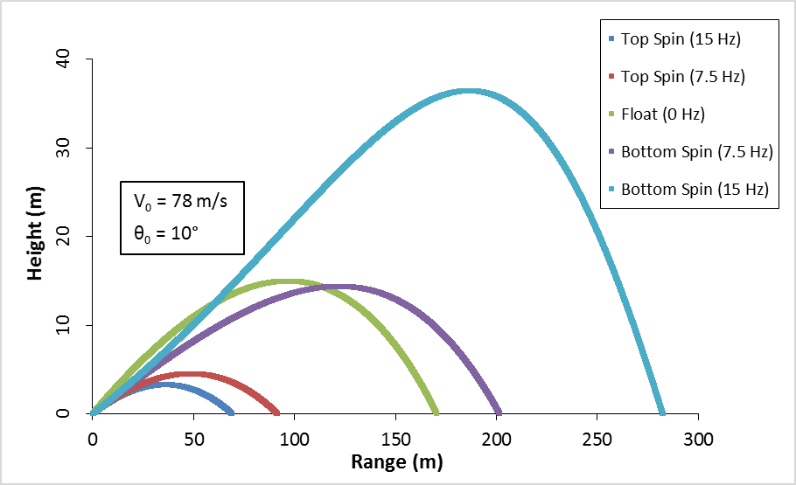

Figure : Trajectories of spinning golf balls (/D=900 x 10-5) at different frequencies, under the influence of drag

Comparing amateur with professional level drives shows the sensitivity of driving range to initial condition of initial velocity, angle of attack and spin rate. Figure 6 shows that a golfer with a professional swing is capable achieving driving ranges that are significantly higher than an amateur.

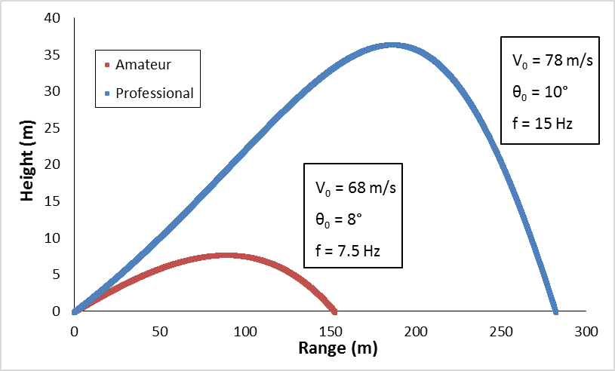

Figure : Trajectories of spinning golf balls (/D=900 x 10-5) for a professional and an amateur golfer

**Link to the golf ball trajectory data (google drive link to the excel file):**

<https://drive.google.com/file/d/0ByS8nVMEtQBDUlA1RjZmYjYzdlk/view?usp=sharing>

Bibliographies:

[1]"Ideal Lift of a Spinning Ball." *Ideal Lift of a Spinning Ball*. Glenn Research Center, NASA. Web. 12 May 2015.

[2]White, Frank M. *Fluid Mechanics*. Boston: McGraw-Hill, 2003. Print.

[3]"Rory McIlroy: What's In The Bag." *Golfalot*. N.p., n.d. Web. 10 May 2015.